Strongly Connected Components (SCC) and Bi-Connected Components (BCC)
SCC
An SCC is a group of vertices where every vertex can reach every other vertex. If you condense each SCC into a single "supernode", the resulting graph is a Directed Acyclic Graph (DAG).
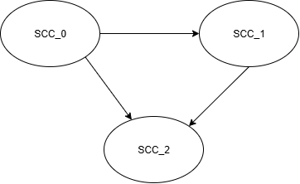
The fact that graph with the “supernodes” is a DAG is the key to understand the algorithms used to extract SCCs.
Note: The above graph contracted a potential multi-graph into a simple graph. In a multi-graph, vertex A can have more than one parallel edges pointing to vertex B. But in a simple graph, there will be only one edge pointing from A to B.
In the above graph:
- It is possible to have more than one edges pointing from SCC_0 to SCC_1
- But all edges must be of the same direction.
- Combing those same direction edges between SCCs, will not change the validity of the discussions below.
Take the graph above as an example, as long as the supernodes makes up a DAG, regardless of the traversal order within each SCC_i, we can be assured the traversal order of the supernodes follow a valid topological order among the supernodes (being a DAG also means once you leave a SCC_i, it will never get back again).
Kosaraju's Algorithm
Key to understand Kosaraju’s algorithm is the supernodes constitute a DAG. Depending on where the DFS starts, there might be different (but all valid) topological orders. But for the above given example, there is the following one valid topological order:
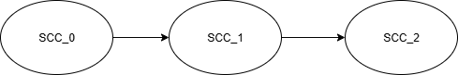
Within each SCC_i, there might be multiple nodes, but we don’t care about the traversal order within each SCC_i. When doing DFS that results in the above SCC_i order, we save the node by finish time in a list, the reverse of that list, will be the “topological order”. Quotes are added to the “topological order”, because there is not really a topological order among the actual nodes (because of the cycles), but the “topological order” of the node clusters (supernodes) is valid: with the above traversal, the reversed_finish_time list will have all nodes within SCC_0 before nodes in SCC_1, before nodes in SCC_2.
Now, if we transpose the graph, meaning reverse all the edges in the graph, we will have the following:
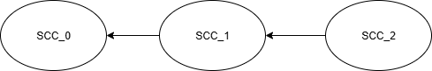
Within each SCC_i each pair of nodes have bi-directional pathways, after transposing, they should still have bi-directional pathways, so they still form a SCC. Among SCC_i and SCC_j, there is only one edge, after transposing, the directions are reversed.
Now if you start DFS following the reversed_finish_time list, you will first traverse all nodes within SCC_0. You can’t get out of the SCC_0, because the only exit edge is now reversed into an incoming edge. This one you get all the nodes within SCC_0.
Then the DFS will proceed to traversal all nodes within SCC_1, then SCC_2.
This way you extract the SCCs with:
- DFS to get the reversed_finish_time list
- Transpose the graph (reversing all edges)
- DFS following the reversed_finish_time order, each inner dfs will extract a SCC, and all SCCs will be extracted one by one.
Tarjan's algorithm
As discussed in Kosaraju’s Algorithm, regardless of where the DFS started, the SCC_i will constitute a DAG. Let’s assume the resulted topological order (from the DFS) among the supernodes are as following.
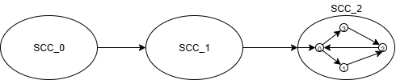
We don’t care from where you entered a SCC, but we know the point of entry will have the earlies discovery time within that same SCC.
But also note that the topological order is decided by finish time instead of discovery time, so the above topological order result, does not mean the dfs starts from SCC_0, then progress to SCC_1, then to SCC_2 and start backtracking from SCC_2 back to SCC-0. The DFS could start from any node within any SCC_i. But that does not change the relative finish time order among the SCCs, in this specific example, as there is only valid topological order.
The idea of the Tarjan's algorithm is trying to design a procedure to classify different SCCs by different discovery time of each SCC. Because we know, the graph composed of the SCCs is a DAG, and thus there are strict topological orders among each cluster. With the above example, if we somehow were able to mark all nodes within SCC_0 with the discovery time of SCC_0, and all nodes within SCC_1 with the discovery time of SCC_1 and same for SCC_2, then we have effectively decomposed the graph into SCCs.
In the Tarjan's algorithm, all nodes within SCC_2, the lowlink will have the discovery time of the discovery time of SCC_2, which is the discovery time of the entry point in SCC_2, which is node_0 inside SCC_2. It doesn’t matter how we entered SCC_2, either from node_0 or from any other node, either entered from SCC_1 or DFS starts directly with an arbitrary node within SCC_2, what matters are 3 things:
- Topologically, SCC_2 is the last of the SCCs, so there will be no traversal out of it. So, it is where the backtrack of the DFS starts.
- Regardless of SCC_2 is entered at node_0, or any node, as long as you entered SCC_2, all nodes within SCC_2 will be traversed, and all nodes will share the same lowlink value as the discovery time of the entry point.
- But only the entry point will have the same lowlink value as the index value. All other nodes within SCC_2 will have larger index values than lowlink value. So, the entry point of SCC_2 is uniquely identified this way.
This is already effectively extracted SCC_2. The remaining question is how to extract SCC_1 and SCC_0. Go back to the high level idea of Tarjan’s algorithm, we already marked nodes in SCC_2 all with the same discovery time by setting to the same lowlink value. The difference between SCC_1 and SCC_2 is SCC_1 is not a leaf node, so if we started DFS from SCC_2, meaning node in SCC_2 will have a smaller lowlink value, we face the risk of propagating the smaller lowlink value from SCC_2 into SCC_1 as nodes in SCC_2 are reachable in SCC_1. We don’t have this problem with SCC_2, because it has no further descendants. So the key here is how we effectively “trim off” the already extracted leaf supernode, then SCC_1, and SCC_0 afterwards all become “leaf” nodes sequentially. That’s where the “stack” in the Tarjan’s algorithm comes into play. By popping off the already “completed” leaf supernodes, the current node, effectively became the “leaf node” in the lowlink propagation sense. The lowlink in the current node has no more effect from descendants.
BCC
Let G=(V, E) be a connected, undirected graph (simple graph). An articulation point of G is a vertex whose removal disconnects G. A bridge of G is an edge whose removal disconnects G. A biconnected component of G is a maximal set of edges such that any two edges in the set lie on a common simple cycle. Figure 22.10 illustrates these definitions.
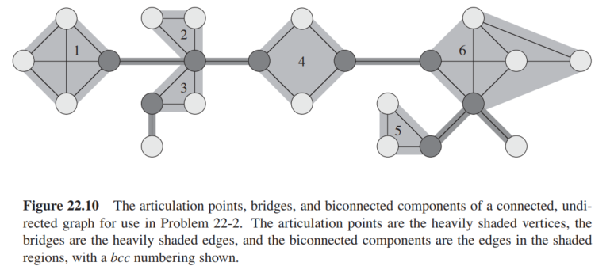
We can determine articulation points, bridges, and biconnected components using depth-first search. More specifically, a variation of Tarjan’s Algorithm.
Note: some explanation over the above definitions. The two crossing diagonal edges of BCC_1 might cause confusion. How do they lie on a common simple cycle? Actually, they are: top bottom left right top, that’s a simple cycle.
“Simple cycle”: a closed loop in the graph with no repeated vertices except for the start/end vertex.
核心思路就是找到articulation point.标准是两个：
- 对于root node来说，需要#child>1. 不能用low[v] >= disc[u]，因为左边不等式在u是root的时候，必然成立，所以并不能证明root是个articulation point.反而，如果在一个undirected graph当中，竟然统计出多于1个的child，说明两个child之间是不直接联通的，root就是唯一链接他们的点。
- 对于非root node来说，就只用关心low[v] >= disc[u].也就是说，没有从v再回到u的ancestor的路径。当然edge (v, u)不能算，就是做dfs的时候，不能往parent走。
上面的定义我摘自CLRS，在上面的定义中，显然没有把bridge当做是BCC，但是在convention中，bridge也被当做BCC:
- A BCC of a single edge is valid because the definition is satisfied vacuously (no pair of edges to check).
- This convention ensures every edge in the graph belongs to exactly one BCC.
Note：在Tarjan Algorithm中，生成的BCC list要么就是bridges，要么最少就有3个edges.

low[v] is the lowest discovery time that can be reached from vertex v using:
Tree edges (DFS edges)
At most one back edge
See example below, it explains why you can use at most one back edge:
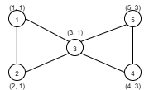

Node, 4 and 5 can only reach node 3, not node 1 following dfs.

